High Level Design (HLD)

Hospital Dataset Analysis

By

***Aman Rajbhar***

# Document Version Control

|  |  |  |  |
| --- | --- | --- | --- |
| **Date Issued** | **Version** | **Description** | **Author** |
| **26th AUG 2024** | 1.0 | Initial draft of the HLD document | Aman Rajbhar |
| **27th AUG 2024** | 1.1 | Added detailed data descriptions | Aman Rajbhar |
| **28th AUG 2024** | 1.2 | Completetion of HLD document | Aman Rajbhar |
|  |  |  |  |

**Contents**

Document Version Control 2

Abstract 3

1 Introduction 4

1.1 Why this High-Level Design Document? 4

1.2 Scope 4

2 General Description 5

2.1 Product Perspective & Problem Statement 5

2.2 Tools used 5

3 Design Details 6

3.1 Functional Architecture 6

3.2 Optimization 7

4 KPIs 8

4.1 KPIs (Key Performance Indicators) 8

5 Deployment 9

# Abstract

Hospital management requires the effective handling and analysis of extensive data related to patient care, medical procedures, and healthcare performance metrics. This project focuses on the utilization of ***SQL+ Power BI*** to analyze a comprehensive hospital dataset, including patient demographics and various healthcare indicators. Through this analysis, the project aims to identify critical areas for improvement, such as reducing patient wait times and optimizing resource allocation. The insights gained will be used to make data-driven recommendations that enhance overall hospital management and improve healthcare outcomes. This work demonstrates the ability to apply data analysis techniques to real-world challenges in the healthcare sector..

# Introduction

## Why this High-Level Design Document?

A Low-Level Design (LLD) document provides a detailed description of how the components of a system will be implemented. It includes specifics about the architecture, data flow, and the process by which data is collected, transformed, and stored. The LLD is critical in translating the high-level design into a blueprint that can be used for development and deployment.

The HLD will:

* Present all of the design aspects and define them in detail
* Describe the user interface being implemented
* Describe the hardware and software interfaces
* Describe the performance requirements
* Include design features and the architecture of the project
* List and describe the non-functional attributes like:

o Security

o Reliability

o Maintainability

o Portability

o Reusability

o Application compatibility

o Resource utilization

o Serviceability

## Scope

The scope of this document covers the architecture, data flow, and implementation details for the SQL-based system designed to handle various tasks such as data extraction (web scraping), transformation, insertion into a database, and exporting data for further analysis. The LLD will focus on the design and implementation details that are necessary for developers to create the system.

# General Description

## Product Perspective & Problem Statement

The project centers around a hospital management system that relies on a vast array of data concerning patient demographics, medical procedures, and healthcare performance metrics. The product, in this context, is a data analysis toolset that leverages SQL to extract, analyze, and interpret data from a hospital dataset.

Hospitals are challenged with managing large volumes of data, including patient records, medical procedures, and performance metrics. However, extracting actionable insights from this data to improve hospital management can be difficult. The objective of the project is to perform data visualization techniques to understand the insight of the data. This project aims apply various Business Intelligence tools such as SQL + Power BI to evaluate healthcare metrics & to get a visual understanding of the data.

## Tools used

Business Intelligence tools Such as MySQL & Power BI are used to build the whole framework.

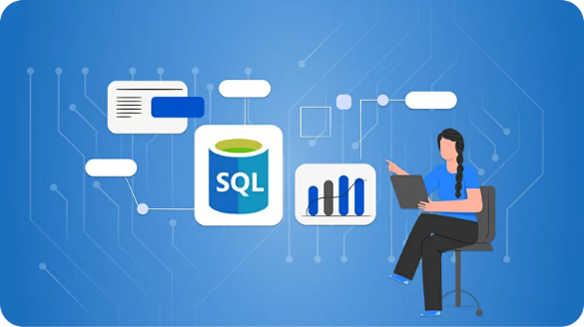

# Design Details

## Functional Architecture

Figure 1: Functional Architecture of Business Intelligence

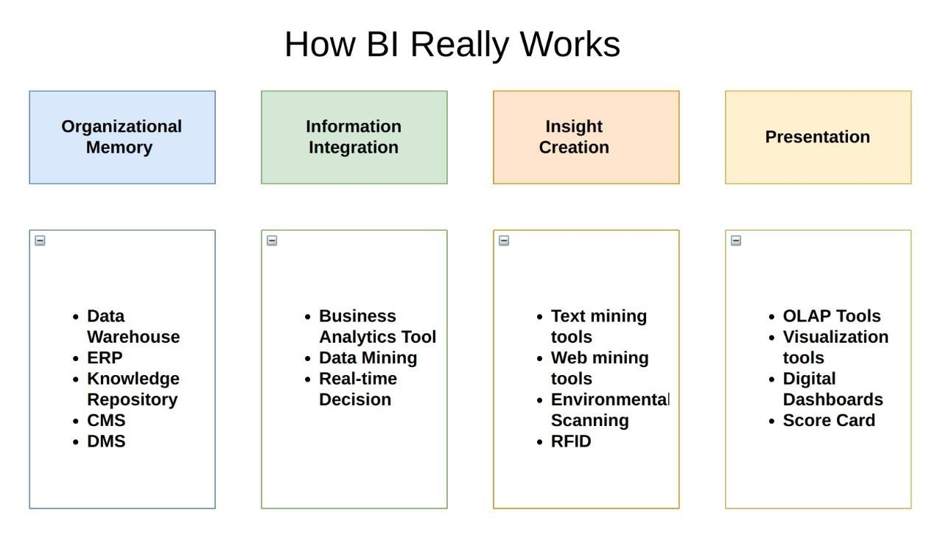

## Optimization

The optimization analysis focuses on identifying and improving key areas within the hospital management system to enhance overall efficiency, reduce costs, and improve patient care outcomes. The following aspects are considered for optimization:

***1. Data Quality and Accuracy***

* **Data Cleaning and Normalization:** Ensuring that patient records, procedure details, and performance metrics are accurate, consistent, and free from errors. This involves identifying and correcting inconsistencies, removing duplicates, and standardizing data formats across the dataset.
* **Regular Data Audits:** Implementing periodic audits of the data to detect and correct issues before they impact decision-making processes.

***2. Resource Allocation***

* **Procedure Cost Analysis:** Analyzing the cost data of various medical procedures to identify outliers or facilities with disproportionately high costs. By optimizing these procedures, the hospital can allocate resources more effectively, reducing unnecessary expenses while maintaining high-quality care.
* **Capacity Planning:** Assessing the utilization of hospital facilities, such as operating rooms and inpatient beds, to ensure that resources are optimally allocated based on patient demand.

***3. Patient Flow and Wait Times***

* **Bottleneck Identification:** Analyzing patient wait times across different departments to identify bottlenecks in the hospital workflow. This could involve examining the time taken for patient registration, diagnosis, treatment, and discharge.
* **Process Streamlining:** Implementing strategies to reduce bottlenecks, such as optimizing scheduling practices, improving communication between departments, or introducing technology solutions like automated check-in systems.

# KPIs

Dashboards will be implemented to display and indicate certain KPIs and relevant indicators for the disease.



As and when, the system starts to capture the historical/periodic data for a user, the dashboards will be included to display charts over time with progress on various indicators or factors

## KPIs (Key Performance Indicators)

Key indicators displaying a summary of the Housing Price and its relationship with different metrics

1. Average Cost of Medical Procedures
2. Maximum Cost of Medical Procedures
3. Minimum Cost of Medical Procedures
4. Patient Satisfaction Rating
5. Procedure Cost Variation
6. Readmission Rate

# Deployment

Prioritizing data and analytics couldn’t come at a better time. Your company, no matter what size, is already collecting data and most likely analyzing just a portion of it to solve business problems, gain competitive advantages, and drive enterprise transformation. With the explosive growth of enterprise data, database technologies, and the high demand for analytical skills, today’s most effective IT organizations have shifted their focus to enabling self-service by deploying and operating Power BI at scale, as well as organizing, orchestrating, and unifying disparate sources of data for business users and experts alike to author and consume content.

Power BI prioritizes choice in flexibility to fit, rather than dictate, your enterprise architecture. Power BI Server and Power BI Online leverage your existing technology investments and integrate into your IT infrastructure to provide a self-service, modern analytics platform for your users. With on-premises, cloud, and hosted options, there is a version of Power BI to match your requirements. Below is a comparison of the Two types:

### Power BI Desktop

* Full control of hardware and software
* Infrastructure and data remain behind your firewall
* Need dedicated administrators to manage hardware and software
* Additional infrastructure needed to access off-network (mobile, external)

### Power BI Server

* Fully hosted solution (hardware, software upgrades)
* Fast to deploy
* Easy for external audience to access
* Single-site in multi-tenant environment
* Cubes are not supported
* No guest account access

Depending on your organizational roles and responsibilities, Power BI Server should be installed by a systems administrator and the designated Power BI Server Administrator in coordination with the appropriate IT roles. For Power BI Online, you will integrate with your existing technology and configure the site settings. The Data & Analytics Survey, completed by business teams, identifies and prioritizes data use cases, audience size, and users. You will use the information collected in both surveys to plan your deployment strategy, including sizing, installation, and configuration of your Power BI Server or integration and configuration of Power BI Online. In addition to installing Power BI Server or configuring Power BI Online, administrators will also need to plan for the client software installation of Power BI Prep Builder, Power BI Desktop, Power BI Mobile, and Power BI Bridge for Power BI Online where applicable.